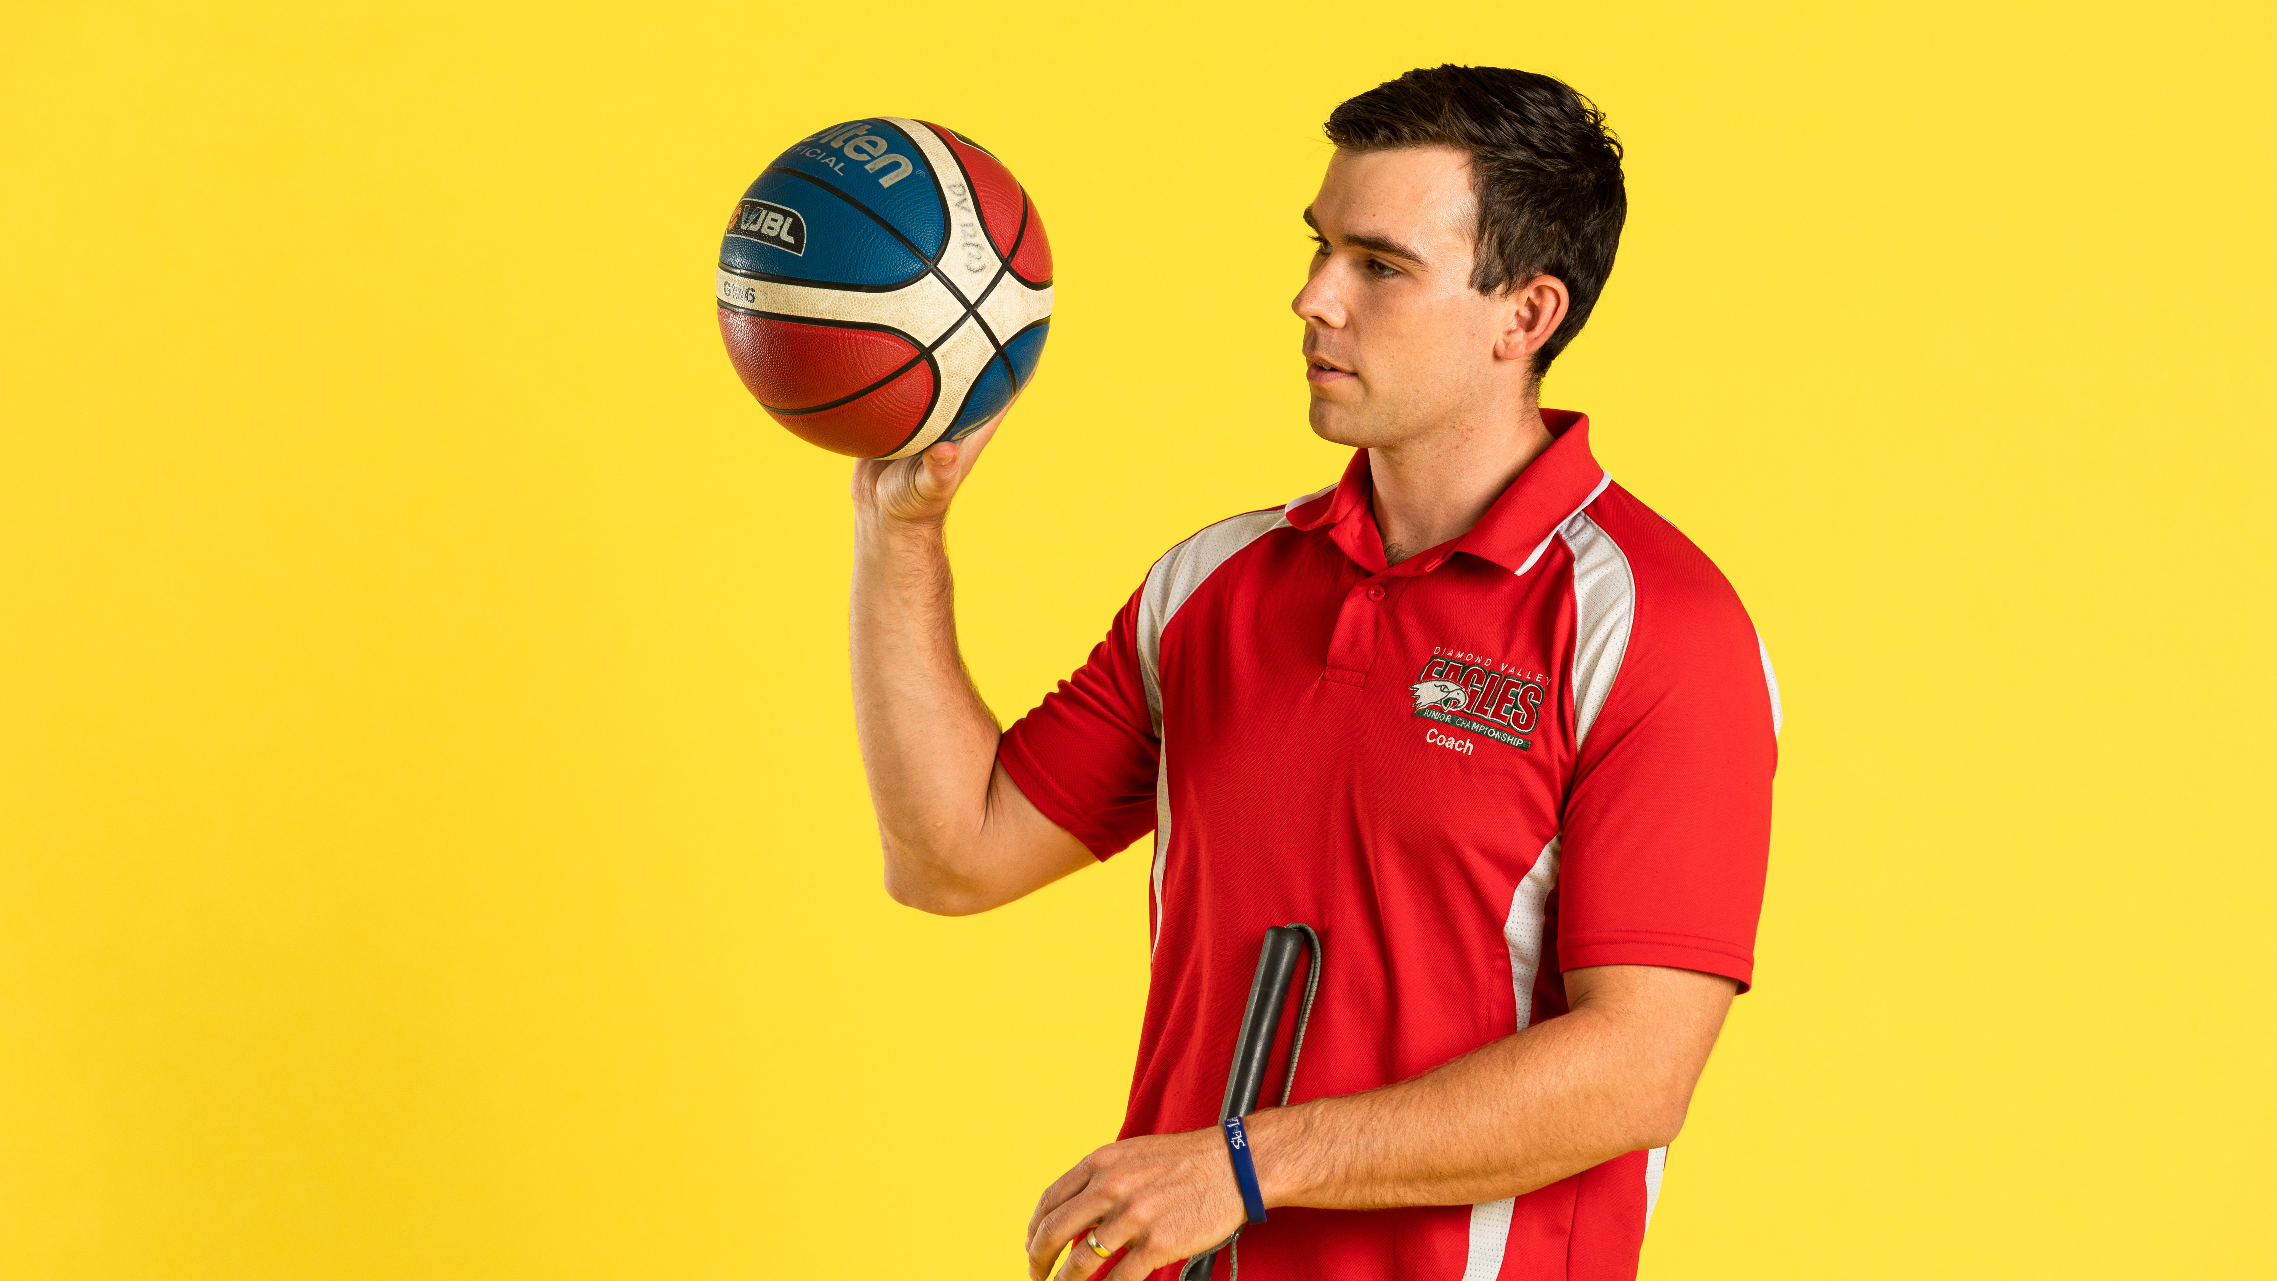

# The Sport4All Inclusion Action Plan

# A blue text on a black background Description automatically generatedSCHOOL

**Pillar 1: Inclusive Environment**

(please assign an action to every value below)

|  |  |  |  |  |
| --- | --- | --- | --- | --- |
| Value | Objectives | Action | Person/s Responsible | Timeframe for Delivery |
| Group Dynamics |  |  |  |  |
| PE and Sport Participation |  |  |  |  |
| Environmental Accessibility |  |  |  |  |

**Pillar 2: Interpersonal Relationships**

(please assign an action to every value below)

|  |  |  |  |  |
| --- | --- | --- | --- | --- |
| Value | Objectives | Action | Person Responsible | Timeframe for Delivery |
| Personal Communication |  |  |  |  |
| Role Involvement |  |  |  |  |
| Have a Voice |  |  |  |  |

**Pillar 3: Community Participation**

(please assign an action to every value below)

|  |  |  |  |  |
| --- | --- | --- | --- | --- |
| Value | Objectives | Action | Person Responsible | Timeframe for Delivery |
| Community Perception |  |  |  |  |
| Social Involvement |  |  |  |  |
| Club Linkages |  |  |  |  |

**Pillar 4: Culture**

(please assign an action to every value below)

|  |  |  |  |  |
| --- | --- | --- | --- | --- |
| Value | Objectives | Action | Person Responsible | Timeframe for Delivery |
| Empathy |  |  |  |  |
| Fairness |  |  |  |  |
| Accountability |  |  |  |  |
| Curiosity |  |  |  |  |
| Trust |  |  |  |  |
| Openness |  |  |  |  |
| Respect |  |  |  |  |